Pedro Montes

https://data.cityofnewyork.us/Public-Safety/Motor-Vehicle-Collisions-Crashes/h9gi-nx95

NYC is a big city with people driving around at all times. The data I am analyzing is the motor vehicle collisions crash table that has been updated since april 2014. This data will help us assess which borough is the most dangerous to drive through so that the city can raise awareness and put the proper safeguards in place to prevent further danger. I started by deleting all missing data because we cannot use incomplete data and deleted unnecessary information for the purposes of this task. I then organized the data by borough. Once I had the desired borough, we can see how many collisions, injuries, and Deaths each borough experienced.

|  |  |  |  |
| --- | --- | --- | --- |
| Borough | Collisions | Injuries | Deaths |
| Manhattan | 236,982 | 43,848 | 241 |
| Bronx | 133,837 | 42,908 | 173 |
| Brooklyn | 300,815 | 97,885 | 419 |
| Queens | 263,823 | 77,344 | 385 |
| Staten Island | 43,268 | 12,030 | 70 |

As we can see the borough with the greatest number of collisions is Brooklyn followed by Queens, Manhattan, The Bronx and lastly Staten Island in that order. Because Brooklyn has the most collisions it makes sense for it to also have the highest number of injuries at 97,885 as well as the highest number of deaths at 419. A few interesting things are also noted. For example The Bronx with 133,837 collisions has the second fewest collisions which is almost half that of Manhattan, however The Bronx seems to have almost just as many injuries as Manhattan. This could be due to the location of The Bronx putting it between many places people often drive to. The Bronx also has many highways going through it which could be part of the reason. Another interesting fact noted was that Queens with almost the same number of collisions as Manhattan has almost double the injuries and almost double the deaths. Not surprisingly Staten Island has the least number of collisions, injuries, and deaths possibly because of its accessibility as well as its location making it far less likely for travelers to go by car.

**Manhattan**

When we take a closer look at the collisions in each borough, we can see that some zip codes do much worse than others when it comes to safety and can be seen by the table below. Using both the histogram and the table below shows a much broader picture of the collisions in manhattan. The numbers on the y axis indicates the amount of zip codes and the number on the x axis indicates the amount of collisions. When we look at this histogram we can see that in Manhattan the majority of collisions happens in a select few zip codes. I will consider anything with greater than 4000 collisions as a high collision area.

We can see that in 7 zip codes there are between 4000 and 4999 collisions. In 6 zip codes there are between 5000 and 5999 collisions. In 3 zip codes between 6000 and 6999 collisions take place and lastly in another 3 zip codes between 7000 and 7300 collisions happen. All together there are 19 zip codes with high collision rates. If we add up all the collisions that these 19 zip codes experienced, we get a total of 107,457 collisions. As we noted earlier, Manhattan has a total of 236,982 collisions in total. That would mean that these 19 out of the 112 zip codes produce almost half of all collisions in Manhattan. So 17% of the zip codes produce 45% of the collisions and thus these zip codes have to be properly monitored with cross guards and other preventative measures to try and decrease the number of crashes.

Manhattan

|  |  |
| --- | --- |
| Zip Code | Number of Collisions |
| 10016 | 7273 |
| 10022 | 7221 |
| 10019 | 7173 |
| 10001 | 6551 |
| 10036 | 6473 |

Manhattan

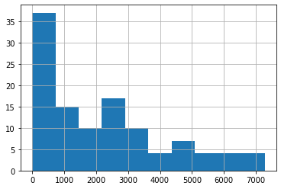

**The Bronx**

As we take a look at the table and histogram for The Bronx we see that the numbers don't go all the way as high to the seven thousands in terms of collisions as Manhattan did. However we also have to note that The Bronx has less zip codes than Manhattan by about half. Therefore we will determine if The Bronx is doing well in terms of collision with respect to itself and not Manhattan or any other borough for that matter. We will do the same for all boroughs but will compare their percent difference in terms of collisions.

From the table we see that 6 zip codes have between 4000 and 4999 collisions. And 2 zip codes have between 5000 and 5500 collisions. When we take the sum of all the collisions in these 8 zip codes we see that they add up to 37,612. When we compare this to all the collisions that take place in The Bronx which is 133,837, we can see that these 8 zip codes out of all 51 make up about 28% of all collisions in The Bronx when they account for only 15% of The Bronx. Proper counter vehicle collision safeguards should be put in place in these 8 zip codes to try and drive that number down.

The Bronx

|  |  |
| --- | --- |
| Zip Code | Number of Collisions |
| 10467 | 5,467 |
| 10458 | 5,051 |
| 10451 | 4,928 |
| 10457 | 4,817 |
| 10453 | 4,639 |
| 10466 | 4,523 |
| 10460 | 4,187 |
| 10468 | 4,000 |

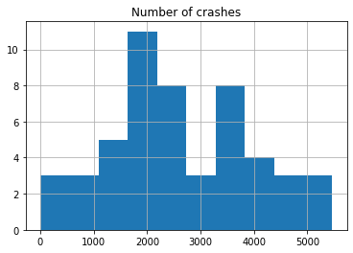

**Brooklyn**

Moving on to Brooklyn we gathered that 30 of the zip codes produce the most collisions.

From the table we see that 15 zip codes have between 4,000 and 4,999 collisions.

4 zip codes have between 5,000 and 5,999 collisions. 6 zip codes have between 6,000 and 6,999 collisions. 3 zip codes have between 7,000 and 7,999 collisions. There is only 1 zip code between 8000 and 8,999. There are no zip codes with the range of collisions between 9,000 to 9999 but there is 1 zip code sitting at 10,762. In total these 30 zip codes make up 170,358 collisions which is more than half of all the collisions in the entirety of Brooklyn at 300,815. When compared to Brooklyn as a whole, these 30 zip codes account for 56% of all collisions when they are 37% of all of Brooklyn.

|  |  |  |  |  |  |
| --- | --- | --- | --- | --- | --- |
| Zip Code | Collisions | Zip Code  (continued) | Collisions  (continued) | Zip Code  (continued) | Collisions  (continued) |
| 11207 | 10,762 | 11233 | 6,164 | 11217 | 4,545 |
| 11201 | 8,445 | 11230 | 5,929 | 11234 | 4,540 |
| 11203 | 7,874 | 11201 | 5,260 | 11204 | 4,447 |
| 11236 | 7,639 | 11211 | 5,110 | 11235 | 4,424 |
| 11234 | 7,550 | 11213 | 5,085 | 11223 | 4,418 |
| 11207 | 6,981 | 11206 | 4,983 | 11226 | 4,361 |
| 11226 | 6,815 | 11203 | 4,967 | 11214 | 4,298 |
| 11212 | 6,804 | 11210 | 4,905 | 11236 | 4,287 |
| 11208 | 6,266 | 11219 | 4,592 | 11220 | 4,085 |
| 11220 | 6,216 | 11218 | 4,575 | 11216 | 4,031 |

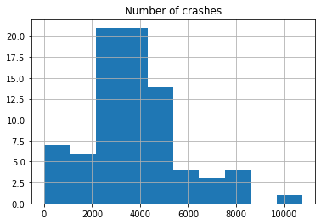

**Queens**

When we look at the charts for Queens we can see that there are 16 zip codes that produce the most amount of collisions. There are 8 zip codes with between 4000 and 4999 collisions, 5 zip codes with between 5000 and 5999 collisions, 1 zip code with 6834 collisions, 1 with 7940 collisions, and lastly 1 with 9117 collisions. When summed all up these 16 zip codes produce 35% of all collisions in Queens and they only account for only 11% of Queens. All these zip codes should have government funded preventative measures but the three zip codes 11101, 11434, and 11385 produce the highest number of collisions in Queens and should have special priority for preventative measures.

|  |  |  |  |
| --- | --- | --- | --- |
| Zip Code | Collisions | Zip Code  (continued) | Collisions  (continued) |
| **11101.0** | 9117 | **11373.0** | 4762 |
| **11434.0** | 7940 | **11375.0** | 4761 |
| **11385.0** | 6834 | **11413.0** | 4717 |
| **11101** | 5922 | **11368.0** | 4498 |
| **11377.0** | 5911 | **11385** | 4437 |
| **11354.0** | 5452 | **11432.0** | 4175 |
| **11420.0** | 5249 | **11422.0** | 4053 |
| **11355.0** | 5000 | **11434** | 4037 |

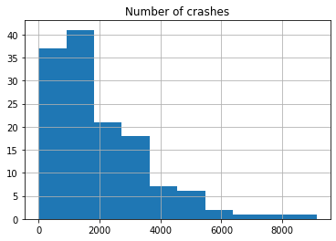

**Staten Island**

Lastly we look at Staten Island. Staten Island has less volume so there and in turn less accidents, so there isn't much data of collisions above 4000. Out of 24 zip codes there is only one with collisions above 4000. That one zip code makes up 4% of all of Staten Island and with 4573 collisions it makes up 10% of all collisions in Staten island. For 1 zip code to make for 10% of collisions is rather a lot.

|  |  |
| --- | --- |
| Zip code | Collisions |
| **10306.0** | 4573 |
| **10304.0** | 3447 |
| **10306** | 3190 |
| **10312.0** | 3106 |
| **10305.0** | 3033 |

